Brent Mellor u0538831

ECE 5780 – Proposal for Final Project

# High-Level Description

The overall goal of this project is to design an intelligent LED lighting controller for use within a lab workspace. A central module will allow the user to interactively adjust the levels and state of each of the output lighting channels. In addition, the device will be capable of measuring various environmental conditions such as ambient light, room occupancy and temperature. An exploded view of the tentative design is shown below:

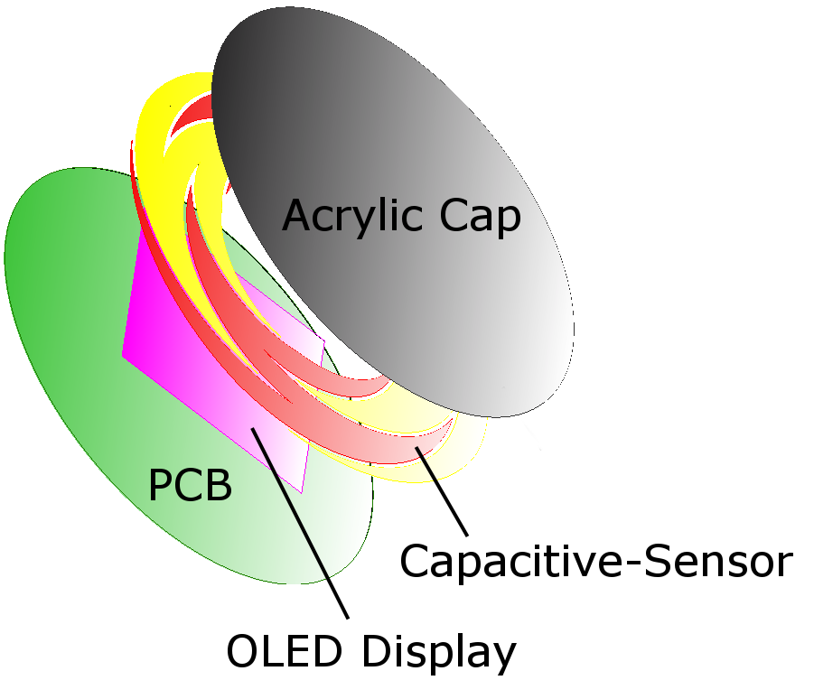

Figure 1: Exploded view of center module.

The major functions of the project are as follows:

1. 6 independently controllable PWM output channels for MOSFET or current-source control/drive.
2. Allowing the user to interact with the system through capacitive-sensing buttons, OLED display and audible feedback (piezo).
3. Software interface to chain outputs as independent or RGB groupings.
4. Software interface to allow for selecting and dimming each output channel. (While keeping accurate color hue during RGB dimming.)
5. User-configurable behavior to automatically turn on/off lighting when entering/exiting the area during low ambient light levels.
6. Measuring and displaying environmental conditions such as temperature and barometric pressure trends.

# Functional and Component Diagrams

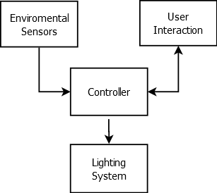

Figure 2: Functional diagram of system.

|  |  |
| --- | --- |
| **Inputs:** | **Outputs:** |
| Capacitive-sensor ring | 6 independently controlled PWM channels |
| CDS or similar (ambient light level) | OLED display |
| PIR (room occupancy) | Piezo speaker |
| Temperature |  |
| Barometric pressure |  |

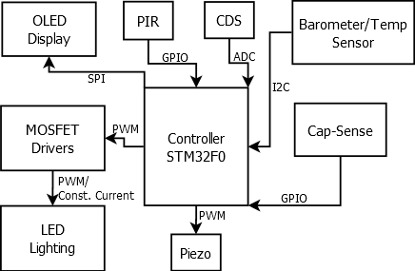

Figure 3: Component diagram of system.

# Preliminary Component List

This list is somewhat incomplete, as additional support components will be required.

* **Power:**
  + LT3990 - Buck-mode switching supply controller by Linear Technology
    - <http://www.linear.com/product/LT3990>
    - Received as samples from Linear
  + PQ1KA903MZPH - 9v LDO from Sharp Microelectronics (EOL = Cheap)
    - <http://www.mouser.com/ProductDetail/Sharp-Microelectronics/PQ1KA903MZPH/?qs=sGAEpiMZZMug9GoBKXZ752jur95v1ZryS9mvDzXqHiE%3d>
* **User Interface:**
  + ER-OLED0.96-3 - 0.96” OLED Display from EastRising
    - <http://www.buydisplay.com/default/oled-display-module.html>
  + PKM13EPYH4000-A0 – Piezo from Murata Electronics
    - <http://www.mouser.com/ProductDetail/Murata-Electronics/PKM13EPYH4000-A0/?qs=sGAEpiMZZMtWZVZ%2fjgUYS0Aer%252bhgfKw%2fwIKQ0QWfrPs%3d>
  + Cap-Sense board fabricated out of Pyralux® AP9111R from Dupont
    - Received as sample material from Dupont
  + Additional components: physical reset button, LED activity indicator.
* **Lighting Driver:**
  + MOSFET drivers not yet determined. Requires either a low Rdson at 3.3v for single power MOSFET drive, or a multi-stage driver using a low-current signal MOSFET to drive a power MOSFET.
  + TPS92550 - 14W Constant Current Buck LED Driver from TI
    - <http://www.ti.com/product/tps92550>
    - Received as samples from TI
* **Sensors:**
  + EKMC1601112 – Board-Mount PIR Sensor by Panasonic Electric Works
    - <http://www.mouser.com/ProductDetail/Panasonic-Electric-Works/EKMC1601112/?qs=sGAEpiMZZMvhQj7WZhFIAH0qPqORKaHAVXeVLRh84QI%3d>
  + CDS Cell – Have a few lying around… Could also use something like the SFH 3711 by OSRAM.
  + BMP085 – Barometric Pressure/Temperature sensor by Bosch Sensortec
    - Superseded by the BMP180, is no longer manufactured. Have one lying around…
* **Controller:**
  + STM32F051C8 48-pin, 32-bit ARM processor by ST Microelectronics
    - <http://www.st.com/web/catalog/mmc/FM141/SC1169/SS1574/LN7>
    - <http://www.mouser.com/ProductDetail/STMicroelectronics/STM32F051C8T6/?qs=sGAEpiMZZMuoKKEcg8mMKIFH%252bydVqf%2frlctMrn%2fLH2U%3d>